COMMON COURSE ASSIGNMENT FORMAT
Name: K. Venugopal Reddy
Registration Number: 192312480
Course Code: ECA5613

A. Assignment Information
Particular | Details
Department | Electronics and Communication Engineering
Programme | Not specified in the supplied assignment question paper
Course Code & Course Name | ECA5613 – 5G/6G Communication Systems
Academic Year / Batch | Not provided
Faculty Name | Not provided
Assignment Title | Design and Development of a 5G/6G-Enabled IoT Network for AI-Driven Crop Yield Prediction in Smart Agriculture
Date of Issue | Not provided
Date of Submission | Not provided
Maximum Marks | 100
Course Outcome(s) – CO | CO1, CO2, CO3, CO4 (Primary), CO5 (Primary)
Bloom's Taxonomy Level | L6 – Create (Primary); L4 – Analyze and L5 – Evaluate as supporting levels
SDG Mapping (SDG 1–17) | SDG 9 – Industry, Innovation and Infrastructure; SDG 15 – Life on Land
Industry / Societal Relevance | Smart agriculture, precision farming, rural connectivity, edge AI, sustainable land/soil management, resilient IoT infrastructure

Course Outcomes and Bloom's Taxonomy
CO | Description
CO1 | Understand and articulate the evolution of mobile communication systems, cellular architecture, spectrum utilization, and interference management in wireless communication networks.
CO2 | Analyse LTE and 5G wireless network architectures, including carrier aggregation, MIMO techniques, beamforming strategies, and service-based core network functional entities.
CO3 | Design spectrum access strategies, waveform generation methods, and multiple access techniques for efficient wireless transmission systems.
CO4 (Primary) | Develop 5G-enabled edge computing and IoT solutions for smart city, healthcare, industrial automation, and intelligent communication applications.
CO5 (Primary) | Evaluate advanced wireless technologies including V2X, AI-based optimization, security mechanisms, and emerging 6G communication systems for industrial and societal applications.
Bloom's Taxonomy Level: L6 – Create (Primary Level). The task requires students to synthesize mMTC/NB-IoT connectivity, satellite/NTN backhaul, edge-AI yield-prediction pipelines and lightweight IoT security into one original, large-scale agricultural network design — supported by L4 (Analyze) and L5 (Evaluate) sub-tasks during testing and justification.

B. Assignment Problem / Challenge
Faculty shall provide a realistic engineering/scientific/computing problem, case, challenge or design requirement related to the Course Outcome.
The assignment should preferably require students to:
- Apply course concepts rather than reproduce theory.
- Identify and analyze the problem.
- Consider requirements and constraints.
- Develop or compare alternative solutions where appropriate.
- Use relevant modern engineering/computing/design tools.
- Interpret results.
- Make and justify engineering decisions.
- Consider appropriate technical, economic, environmental, societal, ethical, safety or sustainability factors wherever relevant.

Assignment Task
Design, develop/simulate, secure, and evaluate a 5G/6G-enabled IoT communication network to support AI-driven crop yield prediction and precision farming across a minimum of 3 geographically distributed farm clusters, with a minimum of 500 connected low-power IoT sensors (soil moisture, temperature, humidity, weather stations), a UAV/drone fleet for aerial crop imaging, livestock-tracking devices, and edge server(s) for on-site data aggregation.
The proposed architecture shall integrate an mMTC-optimized network slice using NB-IoT/LTE-M for large-scale, low-power, wide-area sensor connectivity, appropriate spectrum/dynamic-spectrum-sharing strategy, Multi-access Edge Computing (MEC) hosting an AI/ML yield-prediction and irrigation-optimization pipeline, satellite/Non-Terrestrial Network (NTN — LEO) backhaul for coverage in remote farmland, lightweight device authentication and encryption suited to constrained IoT endpoints, and anomaly/spoofing detection for sensor data integrity.
Students shall validate the proposed architecture using suitable network simulation/emulation tools (e.g., NS-3, MATLAB 5G Toolbox/IoT modules, OMNeT++, Mininet/ONOS for SDN-based control) by conducting at least four controlled security/attack scenarios (e.g., sensor/data spoofing, jamming, DDoS on the edge/cloud aggregation point, MITM on data-upload links) and evaluating the network using a minimum of six measurable parameters such as latency, packet delivery ratio, throughput, network availability/coverage, energy consumption per device, and threat detection time.
Students shall analyze the results, assess the scalability, energy-efficiency, resilience and prediction-pipeline reliability of the proposed architecture, and justify the major engineering decisions and technology choices made, including their alignment with the mapped Sustainable Development Goals.

C. Problem Statement

Problem / Case / Design Challenge
A large agricultural deployment requires reliable wireless connectivity for dense, battery-operated field sensors across geographically separated farms. The network must simultaneously support low-rate periodic sensing, higher-rate UAV aerial imagery, livestock tracking, edge processing and resilient remote backhaul. The final system must provide trustworthy data for AI-driven crop-yield prediction and precision irrigation while maintaining security and acceptable energy consumption.
The design must therefore combine 5G/6G networking, mMTC/NB-IoT/LTE-M, spectrum sharing, network slicing, MEC, AI/ML, LEO/NTN backhaul and lightweight IoT security in one cohesive architecture.

D. Requirements and Constraints
Category | Required consideration
Functional requirements | Minimum 3 geographically distributed farm clusters; minimum 500 low-power IoT sensors; soil moisture, temperature, humidity and weather-station sensing; UAV/drone aerial imaging; livestock tracking; edge server(s).
Performance requirements | Evaluate latency, packet delivery ratio, throughput, network availability/coverage, energy consumption per device and threat detection time.
Technical constraints | Low-power/wide-area connectivity; constrained IoT endpoints; heterogeneous traffic; intermittent remote connectivity; scalable device management.
Network requirements | mMTC-optimized slice using NB-IoT/LTE-M; suitable spectrum/dynamic-spectrum-sharing strategy; 5G/6G core and radio architecture.
Edge/AI requirements | MEC hosting AI/ML crop-yield prediction and irrigation-optimization pipeline; local aggregation and inference.
Backhaul | Satellite/NTN (LEO) backhaul for remote farmland coverage and resilience.
Security/privacy | Lightweight device authentication and encryption; anomaly/spoofing detection; protection of sensor data and data-upload links.
Security testing | At least four controlled scenarios: sensor/data spoofing, jamming, DDoS on edge/cloud aggregation, and MITM on data-upload links.
Simulation/tools | NS-3, MATLAB 5G Toolbox/IoT modules, OMNeT++, Mininet/ONOS or equivalent platforms.
Reliability | Assess scalability, energy efficiency, resilience and prediction-pipeline reliability.
Sustainability | Explicit alignment with SDG 9 and SDG 15; responsible resource use and agricultural data handling.
Safety/ethics | Fail-safe operation, human oversight for critical irrigation decisions, privacy and professional reporting of results.
Cost/time/resources | Use simulation/emulation evidence and available computing resources; actual hardware deployment is not mandatory unless separately specified.

E. Student Work

1. Problem Understanding and Formulation
Explain:
- What is the problem?
- What are the expected outcomes?
- What information/data is available?
- What assumptions are made?
- What constraints must be satisfied?

1.1 Proposed Formulation
The system is modeled as three geographically distributed farm clusters containing a dense population of low-power sensing nodes. A practical design uses 510 sensors (170 per cluster) to provide margin above the required minimum of 500. Each cluster also contains gateway connectivity, access to an mMTC slice, MEC processing and access to UAV/livestock data. The output is a reliable stream of validated features and AI predictions for crop yield and irrigation decisions.

2. Application of Course Knowledge
Identify and apply the relevant:
- Principles
- Theories
- Mathematical models
- Algorithms
- Engineering concepts
- Scientific concepts
- Design methodologies
Show necessary calculations, derivations or reasoning.

2.1 Applied 5G/6G and IoT Concepts
- 5G/6G radio access and service-based core network concepts.
- mMTC for massive low-power device connectivity.
- NB-IoT/LTE-M for wide-area constrained endpoints.
- Network slicing for service isolation and traffic prioritization.
- Spectrum allocation and dynamic spectrum sharing.
- MEC for low-latency local data processing.
- LEO/NTN for resilient remote-area backhaul.
- Lightweight authentication, encryption and anomaly/spoofing detection.
- AI/ML inference for crop-yield prediction and irrigation optimization.

3. Solution / Design / Methodology
Develop the proposed solution. Depending upon the nature of the course, this may include:
- Design
- Algorithm
- Model
- Circuit
- Architecture
- Experiment
- Process
- Prototype
- Simulation
- Case analysis
- Data analysis
- Mathematical solution
Where appropriate, consider more than one possible solution.
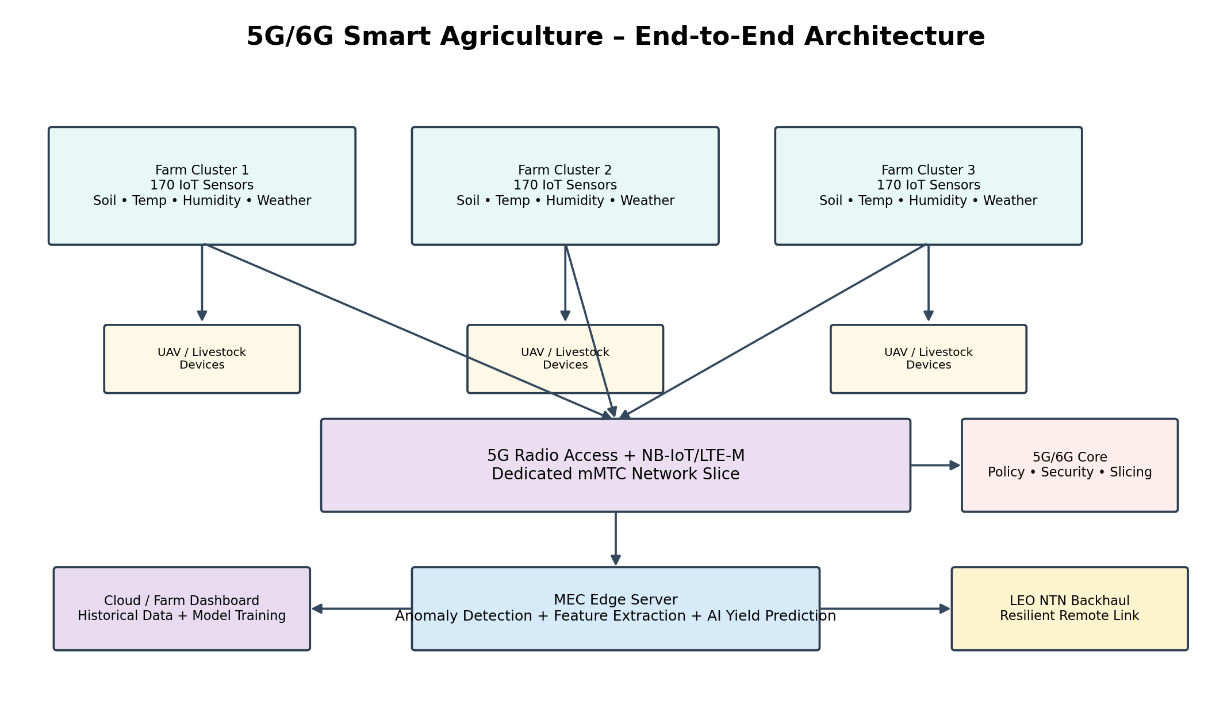
Figure 1. Logical architecture showing farm clusters, IoT sensing, 5G/6G connectivity, MEC/AI, NTN backhaul and cloud.

3.1 Logical and Physical Architecture
Layer | Main components | Function
Field sensing layer | Soil moisture, temperature, humidity and weather sensors; livestock trackers | Collect periodic environmental and asset data.
Aerial layer | UAV/drone fleet with cameras/sensors | Capture crop imagery and high-rate observations.
Access/gateway layer | IoT gateways, 5G/6G radio access, NB-IoT/LTE-M connectivity | Aggregate field traffic and provide wireless access.
mMTC network slice | Dedicated agricultural slice | Scale to dense low-power endpoints and isolate traffic.
MEC layer | Edge server(s) | Local aggregation, preprocessing, anomaly detection and AI inference.
Core/control layer | 5G service-based core functions and policy/control | Authentication, session/policy management and service connectivity.
NTN backhaul | LEO satellite/NTN path | Provide alternate/remote backhaul and resilience.
Cloud analytics | Central analytics/storage backend | Long-term storage, model training/analysis and fleet-level reporting.

3.2 Sensor and Device Population
Farm cluster | Low-power sensors | Other devices | Primary role
Cluster 1 | 170 | UAV + livestock trackers | Environmental sensing and local AI support
Cluster 2 | 170 | UAV + livestock trackers | Environmental sensing and local AI support
Cluster 3 | 170 | UAV + livestock trackers | Environmental sensing and local AI support
Total | 510 | Fleet distributed across clusters | Scalable baseline above 500 sensors

3.3 mMTC Network Slicing
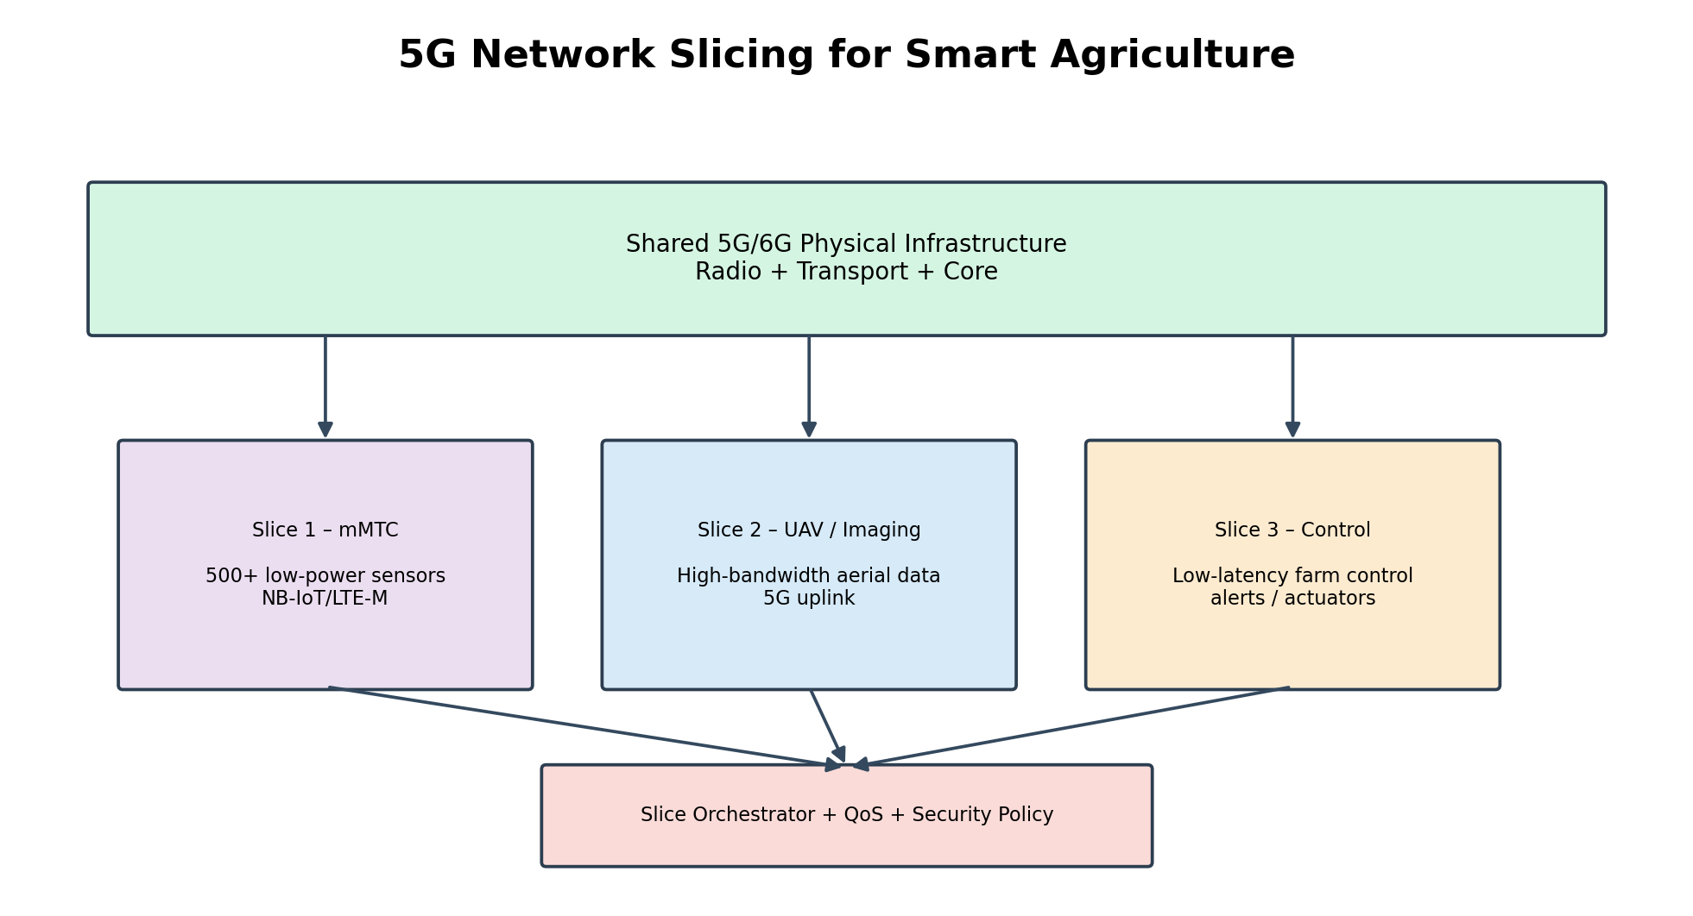
Figure 2. Dedicated mMTC network slice and differentiated traffic treatment.
The agricultural mMTC slice is optimized for dense, low-rate and low-power sensor traffic. UAV traffic can be assigned a separate service treatment so that bursty aerial-imaging data does not degrade critical sensor messages. Priority policies can give emergency irrigation and security alerts higher scheduling priority.

3.4 Spectrum / Dynamic Spectrum Sharing
- Provide reliable coverage resources for periodic sensor traffic.
- Adapt resource allocation according to interference and traffic demand.
- Allow additional resources during UAV image-transfer bursts.
- Prioritize emergency irrigation and security messages.
- Record channel/resource utilization for quantitative evaluation.

3.5 MEC and Edge-AI Pipeline
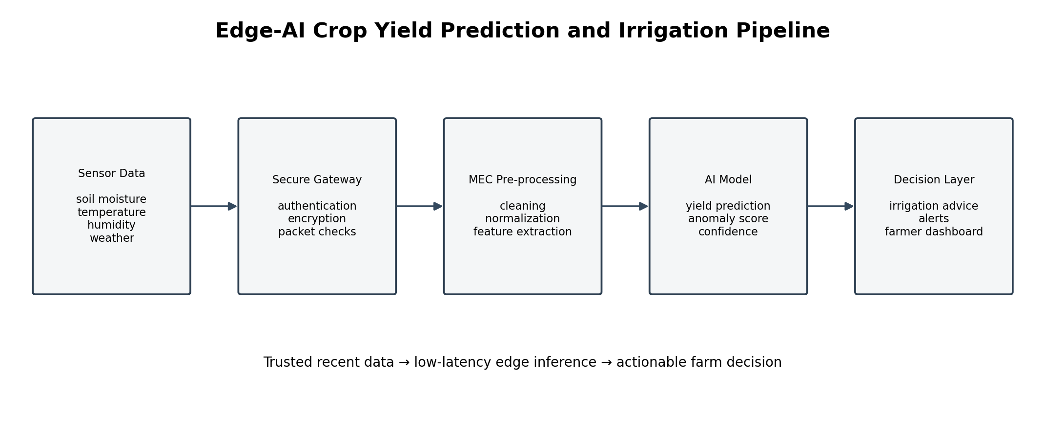
Figure 3. MEC-based AI/ML crop-yield prediction and irrigation-optimization pipeline.
Stage | Processing
Data acquisition | Receive sensor, weather, UAV and livestock data.
Validation | Check timestamps, ranges, missing values and device identity.
Preprocessing | Filtering, normalization, aggregation and feature extraction.
AI inference | Run crop-yield prediction model at the MEC node.
Optimization | Generate irrigation recommendations using predicted yield/crop-state features.
Decision delivery | Send recommendations/alerts to actuators, gateways or farm operators.
Cloud synchronization | Forward summaries/model updates for long-term analytics and training.

3.6 LEO/NTN Backhaul and Resilience
LEO/NTN backhaul provides an alternate communication path for remote farmland. A gateway or network controller can monitor terrestrial-link health and switch or load-share traffic toward NTN when terrestrial connectivity is degraded. MEC processing allows essential decisions to continue locally even when remote cloud connectivity is interrupted.

3.7 IoT Security Architecture
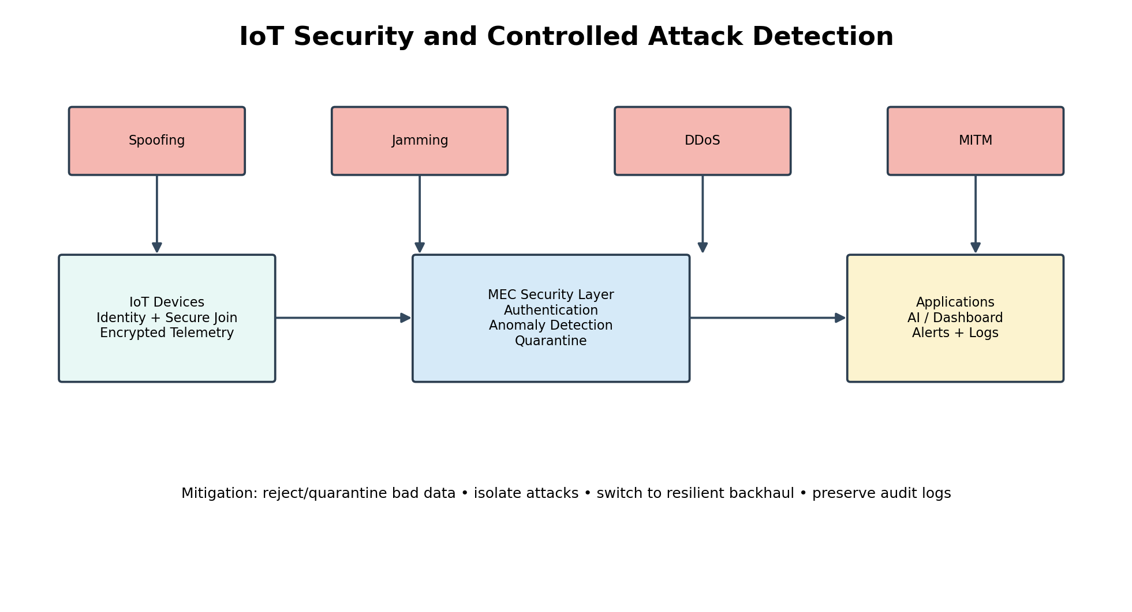
Figure 4. Lightweight IoT authentication, encryption and anomaly/spoofing-detection architecture.
Security control | Purpose
Device authentication | Ensure only authorized endpoints join the agricultural IoT service.
Lightweight encryption | Protect constrained-device communications with manageable computation/energy cost.
Integrity validation | Detect altered or inconsistent sensor measurements.
Anomaly detection | Identify unusual traffic or sensor behavior.
Spoofing detection | Detect false sensor identities or implausible measurement patterns.
Access control | Restrict configuration, data and AI services to authorized roles.
Logging | Maintain evidence for incident analysis and security testing.

3.8 Controlled Security / Attack Scenarios
Scenario | Methodology | Detection / mitigation | Observation to record
Sensor/data spoofing | Inject false sensor values or identities. | Range/correlation checks, authentication and anomaly detection. | Detection time, false/true alerts, PDR and prediction impact.
Jamming | Increase interference or deliberately disrupt radio access. | Channel monitoring, adaptive resources, retry/fallback and resilience mechanisms. | Availability, latency, PDR and recovery time.
DDoS on edge/cloud aggregation | Generate excessive requests toward aggregation point. | Rate limiting, admission control, traffic isolation and filtering. | Service degradation, detection time and recovery.
MITM on data-upload links | Attempt to intercept/alter data in transit. | Mutual authentication, encryption and integrity protection. | Alteration detection, latency overhead and successful mitigation.

4. Use of Modern Tools
Use appropriate tools wherever relevant.
Tool | Use in this assignment | Evidence expected
NS-3 | Large-scale IoT/5G network, traffic, latency, PDR, throughput and attack simulations. | Topology/configuration files, logs, graphs and result tables.
MATLAB 5G Toolbox / IoT modules | 5G/6G radio, channel, algorithm and AI-related studies. | Model setup, screenshots and plots.
OMNeT++ | Discrete-event network evaluation and comparison. | Simulation project, traces and metric plots.
Mininet/ONOS | SDN-based control, traffic engineering and slicing experiments. | Flow rules, topology and controller evidence.
Equivalent tools | Any justified equivalent simulation/emulation environment. | Tool configuration and reproducible outputs.
Students shall provide appropriate evidence of tool usage and outputs.

5. Results and Validation
Present the results using appropriate:
- Tables
- Graphs
- Simulation outputs
- Experimental observations
- Screenshots
- Performance metrics
- Statistical analysis
- Test results
Validate whether the proposed solution satisfies the stated requirements.
Metric | Definition / validation purpose | Required evidence
Latency | End-to-end or sensor-to-MEC delay. | Average, percentile/worst-case values and graph.
Packet Delivery Ratio | Successfully received packets divided by transmitted packets. | Percentage under normal and attack conditions.
Throughput | Useful data rate delivered through the network. | Sensor and UAV traffic throughput plots.
Network availability / coverage | Fraction of time/area with usable connectivity. | Normal vs failure/jamming comparison.
Energy consumption per device | Energy used by a constrained IoT endpoint. | Per-device/cluster energy trend.
Threat detection time | Time between attack onset and detection/alert. | Attack timeline and detection log.
Additional useful metrics may include recovery time, inference latency, prediction error, false-positive rate, model freshness and control-message overhead.

5.1 Result Table Template
Scenario | Latency | PDR | Throughput | Availability | Energy/device | Threat detection time
Normal operation | To be measured | To be measured | To be measured | To be measured | To be measured | N/A
Sensor spoofing | To be measured | To be measured | To be measured | To be measured | To be measured | To be measured
Jamming | To be measured | To be measured | To be measured | To be measured | To be measured | To be measured
DDoS | To be measured | To be measured | To be measured | To be measured | To be measured | To be measured
MITM | To be measured | To be measured | To be measured | To be measured | To be measured | To be measured

6. Analysis and Engineering Decision
Interpret the results.
- Compare alternatives.
- Identify advantages and limitations.
- Discuss trade-offs.
- Explain why the final solution was selected.
- Justify the decision using quantitative or qualitative evidence.

6.1 Engineering Trade-offs
Decision | Benefit | Trade-off / limitation
NB-IoT/LTE-M mMTC slice | Large-scale low-power connectivity. | Lower data rate than broadband access.
MEC inference | Lower decision latency and reduced backhaul load. | Requires edge compute resources and management.
Network slicing | Isolation and traffic prioritization. | Adds orchestration/control complexity.
Dynamic spectrum sharing | Improves spectrum utilization under changing demand. | Interference/resource-management complexity.
LEO/NTN backup | Extends coverage and improves resilience. | Additional latency, capacity and operational constraints.
Lightweight security | Better fit for constrained endpoints. | Security mechanisms must balance protection and device energy.
UAV imagery | Rich spatial information for AI. | High-rate burst traffic and energy requirements.

6.2 Scalability, Energy Efficiency, Resilience and Prediction Reliability
- Scalability: hierarchical aggregation, mMTC access and slice isolation allow the design to grow beyond 500 devices.
- Energy efficiency: periodic sensing, event-triggered reports, lightweight security and local processing reduce unnecessary communication.
- Resilience: MEC continues critical functions during cloud/backhaul disruption, while LEO/NTN provides an alternate path.
- Prediction reliability: validated data, freshness monitoring, anomaly detection and inference-latency measurement improve trust in AI outputs.

7. Broader Considerations
- Sustainability
- Environment
- Society
- Safety
- Ethics
- Economics
- Accessibility
- Professional responsibility
The architecture aligns directly with SDG 9 through resilient digital/rural communication infrastructure and with SDG 15 through data-driven sustainable land and soil management. Farmer and livestock data should be protected, critical decisions should retain appropriate human oversight, and all simulation/security/AI results should be reported honestly.

8. Conclusion
Summarize:
- Proposed solution
- Major findings
- Achievement of requirements
- Limitations
- Possible improvements
The final conclusion should explicitly state whether the three-cluster, 500+ sensor, mMTC, MEC/AI, NTN and security requirements were satisfied and should reference measured validation results.

9. Student Reflection
The supplied assignment requires an individual reflection addressing the following eight points:
- (i) Most challenging aspect of the problem.
- (ii) Most useful 5G/6G/IoT concept.
- (iii) Most useful security/AI concept.
- (iv) Technical problem encountered.
- (v) How the technical problem was solved.
- (vi) Lessons learned from modern tools.
- (vii) Engineering decision that the student would change.
- (viii) How the assignment improved understanding of real-world agricultural IoT networks and its SDG relevance.
The assignment rubric specifies a thoughtful 300–500 word reflection addressing all required questions with clear evidence of learning and critical self-assessment.

10. References
Use an appropriate citation format and acknowledge all external sources, datasets, standards, software and AI-assisted tools used.
- 3GPP TS 23.501 – System Architecture for the 5G System.
- 3GPP specifications relevant to NB-IoT and LTE-M.
- 3GPP specifications and technical work related to Non-Terrestrial Networks (NTN).
- NS-3 Network Simulator documentation and relevant model documentation.
- MATLAB 5G Toolbox and IoT-related documentation.
- OMNeT++ simulation framework documentation.
- Mininet and ONOS documentation for SDN-based experiments.
- United Nations Sustainable Development Goals – SDG 9 and SDG 15.

F. Common Assessment Rubric
The assignment question paper provides a detailed rubric with four performance levels. The complete criterion descriptions are reproduced below so that no rubric component is omitted.
Assessment Criterion | Marks | Level 4 (Exemplary) | Level 3 (Proficient) | Level 2 (Developing) | Level 1 (Beginning)
1. Problem Understanding & Requirements Formulation | 10 | Clearly identifies all requirements: 3 farm clusters, 500+ IoT sensors, UAV/livestock devices, low-power/wide-area connectivity, and SDG needs. | Identifies most requirements with minor omissions. | Identifies basic IoT/agricultural network requirements but lacks completeness. | Requirements poorly understood or incomplete.
2. Application of 5G/6G Networking, IoT & Core Concepts | 20 | Correctly and originally applies NB-IoT/LTE-M, mMTC slicing, spectrum-sharing and SBA core concepts to a large-scale, low-power agricultural scenario. | Applies most concepts correctly with minor technical errors. | Partial/incorrect implementation of required IoT and core concepts. | Major gaps in IoT connectivity and core network concepts.
3. Solution Design: mMTC Slicing, MEC/Edge-AI, NTN Backhaul & Security Integration | 20 | Fully integrated design with justified mMTC slice, MEC-hosted edge-AI yield pipeline, satellite/NTN backhaul, and lightweight IoT security; all components operate cohesively. | Most required components implemented and integrated with minor issues. | Basic design completed but lacks full integration of slicing/edge-AI/backhaul/security elements. | Incomplete design with major architectural or configuration flaws.
4. Use of Appropriate Modern Tools & Simulation Techniques | 10 | Effectively uses simulation/emulation, IoT and AI/ML tools and correctly interprets outputs relevant to large-scale sensor networks. | Appropriate tools used correctly with adequate evidence. | Limited use of tools or insufficient utilization of outputs. | Minimal or inappropriate use of engineering tools.
5. Results, Security Testing & Performance Validation | 15 | All four+ attack scenarios executed with clear detection/mitigation evidence; all six+ metrics collected with rigorous analysis including energy-efficiency trends. | Required testing completed with adequate metric collection and analysis. | Limited testing, fewer attack scenarios, or incomplete metric evaluation. | Insufficient testing and validation.
6. Analysis, AI-Driven Yield Optimization & Engineering Justification | 15 | Thoroughly evaluates scalability, energy efficiency, resilience, NTN backhaul benefits and edge-AI yield-prediction effectiveness; design decisions justified using data and results. | Sound analysis with reasonable justification of design choices. | Limited analysis and weak justification. | Conclusions unsupported by evidence.
7. Broader Considerations: SDG Alignment, Ethics & Professional Responsibility | 5 | Demonstrates strong, explicit alignment with all six mapped SDGs, farmer-data privacy, environmental/resource-use responsibility, and professional practice. | Addresses most broader/SDG considerations adequately. | Limited discussion of SDG, ethical or professional implications. | Negligible consideration of broader impacts.
8. Technical Documentation & Reflection | 5 | Professional report and a thoughtful 300–500 word reflection addressing all required questions with clear evidence of learning and critical self-assessment. | Complete report and reflection addressing most questions with good insight. | Reflection addresses only some questions or lacks depth; documentation partially complete. | Poor documentation and/or missing, superficial, or incomplete reflection.
TOTAL: 100

3. Submission Requirements
Students shall submit the following deliverables as part of the assignment evaluation:
S. No. | Deliverable | Description
1 | Technical Report | Comprehensive report (15–25 pages) covering requirements analysis, IoT/agricultural network architecture, implementation methodology, security design, testing procedures, results, analysis, engineering decisions, SDG alignment and conclusions.
2 | Network Architecture Diagram | Logical and physical topology showing farm clusters, NB-IoT/LTE-M sensor layer, UAV/livestock devices, MEC/edge-AI node, satellite/NTN backhaul, and cloud analytics backend.
3 | Spectrum & mMTC Slicing Design Document | Spectrum/dynamic-spectrum-sharing plan, mMTC slice definition, NB-IoT/LTE-M configuration rationale, and satellite/NTN backhaul design.
4 | Configuration Files / Screenshots | Configurations/evidence for IoT device provisioning, slice configuration, MEC/edge-AI deployment, device authentication and encryption settings, and anomaly-detection rules.
5 | Simulation / Emulation Project Files | Original project files generated using NS-3, MATLAB 5G/IoT Toolbox, OMNeT++, Mininet/ONOS, or equivalent platforms.
6 | Security Testing Evidence | Documentation and screenshots/logs of at least four controlled attack scenarios (sensor/data spoofing, jamming, DDoS, MITM on data upload), including methodology, detection mechanism, mitigation, and observations.
7 | Performance Evaluation Results | Collected data, graphs and tables for at least six evaluation metrics such as latency, packet delivery ratio, throughput, network availability/coverage, energy consumption per device, and threat detection time.
8 | Edge-AI Yield Prediction Evidence | Screenshots/logs and results demonstrating the edge-AI/ML yield-prediction and irrigation-optimization pipeline, including sample predictions and data-freshness/latency of the inference loop.
9 | Engineering Analysis & Design Justification | Discussion of scalability, energy efficiency, resilience, trade-offs, limitations, and justification of key technology and design choices, with explicit SDG mapping.
10 | Individual Reflection | Individual reflection addressing: (i) most challenging aspect, (ii) most useful 5G/6G/IoT concept, (iii) most useful security/AI concept, (iv) technical problem, (v) solution, (vi) lessons from modern tools, (vii) engineering decision to change, and (viii) improved understanding of real-world agricultural IoT and SDG relevance.

G. CO–PO–Assessment Mapping
Assessment Component | CO | PO(s) | Bloom's Level | Marks
Problem formulation | CO4/CO5 | PO1, PO2 | L3/L4 | 10
Application of knowledge | CO4 | PO1, PO2, PO3 | L3/L4 | 20
Solution / Design / Implementation | CO5 | PO3, PO5 | L4/L5/L6 | 20
Modern tool usage | CO5 | PO5 | L3/L4 | 10
Validation | CO5 | PO4, PO5 | L4/L5 | 15
Analysis & justification | CO4/CO5 | PO2, PO3 | L4/L5 | 15
Broader considerations | CO4 | PO6, PO7 | L4/L5 | 5
Documentation & reflection | CO5 | PO10, PO12 | L3/L4 | 5
Note: Faculty shall map only the POs and Bloom's levels genuinely assessed by the particular assignment. Every assignment is not required to map to every PO.

H. Faculty Evaluation & Continuous Improvement

CO Attainment
Performance Level | Criterion
Level 3 | ≥ 70%
Level 2 | 60–69%
Level 1 | 50–59%
Level 0 | < 50%
Target CO Attainment: ______________________________
Actual CO Attainment: ______________________________
Faculty Analysis
Areas in which students performed well: ______________________________________________
Areas requiring improvement: ________________________________________________________
Corrective / Improvement Action: ____________________________________________________
Action to be implemented in the next offering: ________________________________________

Documents to be Maintained
The department/course faculty shall maintain:
- Assignment question/problem statement
- CO–PO and Bloom's mapping
- Assessment rubric
- Student submissions
- Tool/simulation/experimental evidence, where applicable
- Evaluated scripts/reports
- Marks and rubric-wise assessment
- CO attainment analysis
- Sample student work representing different performance levels
- Faculty analysis and continuous-improvement action

Student Submission Details
Particular | Student Details
Name | K. Venugopal Reddy
Register No. | 192312480
Course Code | ECA5613
Course Name | 5G/6G Communication Systems
Assignment Title | Design and Development of a 5G/6G-Enabled IoT Network for AI-Driven Crop Yield Prediction in Smart Agriculture

